# 1、购物车中心

## 1.1 新增购物车条目

输入参数：

userAccountId: 1

goodsSkuId: 1

返回值：true

数据库现场：

购物车表，新增一条数据

购物车条目表，新增一条数据

## 1.2 反复新增购物车条目

输入参数：

userAccountId: 1

goodsSkuId: 1

返回值：true

两次请求这个接口，得到的数据库现场：

购物车表，就是一条数据

购物车条目表，也是一条数据，但是第二次请求过后，购买数量会加1

## 1.3 查看购物车

**1、数据库现场**

**（1）shopping\_cart表**

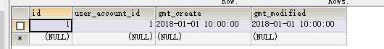

**（2）shopping\_cart\_item表**

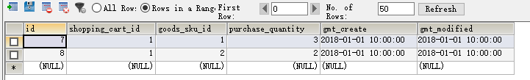

**2、请求参数**

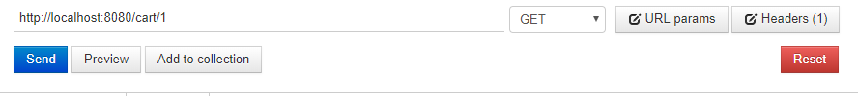

**3、响应结果**

{

"id": 1,

"userAccountId": 1,

"gmtCreate": 1514772000000,

"gmtModified": 1514772000000,

"shoppingCartItemVOs": [

{

"id": 7,

"shoppingCartId": 1,

"goodsSkuId": 1,

"goodsSkuCode": "FDL04300234",

"goodsName": "iPhonePlus",

"saleProperties": "机身颜色:白色,机身存储:256G",

"salePrice": 9599.5,

"grossWeight": 599.8,

"goodsLength": 125.9,

"goodsWidth": 29.6,

"goodsHeight": 59.5,

"saleStockQuantity": 1159,

"goodsId": 999,

"purchaseQuantity": 3,

"promotionActivityDTOs": [

{

"id": 1,

"promotionActivityName": "测试促销活动1",

"promotionActivityStartTime": 1514858400000,

"promotionActivityEndTime": 1515549600000,

"promotionActivityComment": "测试促销活动1",

"promotionActivityStatus": 1,

"promotionActivityRule": "测试促销活动的规则",

"gmtCreate": 1514772000000,

"gmtModified": 1514772000000

},

{

"id": 1,

"promotionActivityName": "测试促销活动2",

"promotionActivityStartTime": 1514858400000,

"promotionActivityEndTime": 1515549600000,

"promotionActivityComment": "测试促销活动2",

"promotionActivityStatus": 1,

"promotionActivityRule": "测试促销活动的规则",

"gmtCreate": 1514772000000,

"gmtModified": 1514772000000

}

],

"gmtCreate": 1514772000000,

"gmtModified": 1514772000000

},

{

"id": 8,

"shoppingCartId": 1,

"goodsSkuId": 2,

"goodsSkuCode": "FDL04300234",

"goodsName": "iPhonePlus",

"saleProperties": "机身颜色:白色,机身存储:256G",

"salePrice": 9599.5,

"grossWeight": 599.8,

"goodsLength": 125.9,

"goodsWidth": 29.6,

"goodsHeight": 59.5,

"saleStockQuantity": 1159,

"goodsId": 999,

"purchaseQuantity": 2,

"promotionActivityDTOs": [

{

"id": 1,

"promotionActivityName": "测试促销活动1",

"promotionActivityStartTime": 1514858400000,

"promotionActivityEndTime": 1515549600000,

"promotionActivityComment": "测试促销活动1",

"promotionActivityStatus": 1,

"promotionActivityRule": "测试促销活动的规则",

"gmtCreate": 1514772000000,

"gmtModified": 1514772000000

},

{

"id": 1,

"promotionActivityName": "测试促销活动2",

"promotionActivityStartTime": 1514858400000,

"promotionActivityEndTime": 1515549600000,

"promotionActivityComment": "测试促销活动2",

"promotionActivityStatus": 1,

"promotionActivityRule": "测试促销活动的规则",

"gmtCreate": 1514772000000,

"gmtModified": 1514772000000

}

],

"gmtCreate": 1514772000000,

"gmtModified": 1514772000000

}

]

}

## 1.4 更新购物车条目购买数量

**1、操作前的数据库现场**

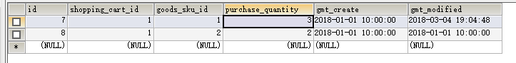

**2、请求参数**

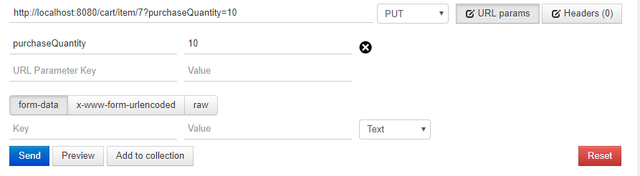

**3、操作后的数据库现场**

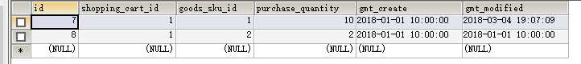

## 1.5 删除购物车条目

**1、操作前的数据库现场**



**2、请求参数**

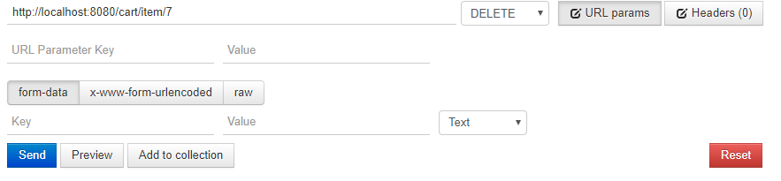

**3、操作后的数据库现场**



# 订单中心

## 2.1 计算订单金额

**1、请求参数**

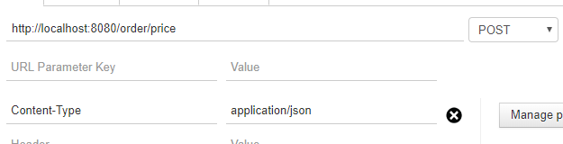

{

"orderItems": [

{

"goodsSkuId": 1,

"purchaseQuantity": 100.0,

"purchasePrice": 3,

"promotionActivityId": 1

},

{

"goodsSkuId": 2,

"purchaseQuantity": 100.0,

"purchasePrice": 3,

"promotionActivityId": 2

}

]

}

**2、响应结果**

{

"id": null,

"orderNo": null,

"userAccountId": null,

"username": null,

"orderStatus": null,

"consignee": null,

"deliveryAddress": null,

"consigneeCellPhoneNumber": null,

"freight": 16.5,

"payType": null,

"totalAmount": 600,

"discountAmount": 20,

"couponAmount": null,

"payableAmount": 596.5,

"invoiceTitle": null,

"taxpayerId": null,

"orderComment": null,

"publishedComment": null,

"confirmReceiptTime": null,

"gmtCreate": null,

"gmtModified": null,

"orderItems": [

{

"id": null,

"orderInfoId": null,

"goodsId": null,

"goodsSkuId": 1,

"goodsSkuCode": null,

"goodsName": null,

"saleProperties": null,

"goodsGrossWeight": null,

"purchaseQuantity": 100,

"purchasePrice": 3,

"promotionActivityId": 1,

"goodsLength": null,

"goodsWidth": null,

"goodsHeight": null,

"gmtCreate": null,

"gmtModified": null

},

{

"id": null,

"orderInfoId": null,

"goodsId": null,

"goodsSkuId": 2,

"goodsSkuCode": null,

"goodsName": null,

"saleProperties": null,

"goodsGrossWeight": null,

"purchaseQuantity": 100,

"purchasePrice": 3,

"promotionActivityId": 2,

"goodsLength": null,

"goodsWidth": null,

"goodsHeight": null,

"gmtCreate": null,

"gmtModified": null

},

{

"id": null,

"orderInfoId": null,

"goodsId": 999,

"goodsSkuId": 3,

"goodsSkuCode": "FDL04300234",

"goodsName": "iPhonePlus",

"saleProperties": "机身颜色:白色,机身存储:256G",

"goodsGrossWeight": 599.8,

"purchaseQuantity": 1,

"purchasePrice": 0,

"promotionActivityId": null,

"goodsLength": 125.9,

"goodsWidth": 29.6,

"goodsHeight": 59.5,

"gmtCreate": null,

"gmtModified": null

}

]

}

## 2.2 计算优惠券抵扣金额

**1、请求参数**

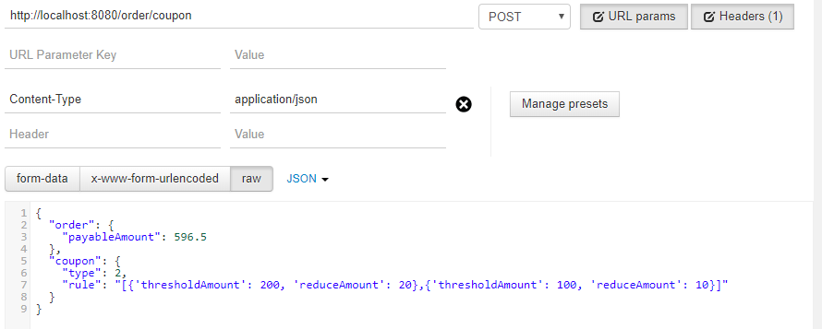

**2、响应结果**

{

"id": null,

"orderNo": null,

"userAccountId": null,

"username": null,

"orderStatus": null,

"consignee": null,

"deliveryAddress": null,

"consigneeCellPhoneNumber": null,

"freight": null,

"payType": null,

"totalAmount": null,

"discountAmount": null,

"couponAmount": 20,

"payableAmount": 576.5,

"invoiceTitle": null,

"taxpayerId": null,

"orderComment": null,

"publishedComment": null,

"confirmReceiptTime": null,

"gmtCreate": null,

"gmtModified": null,

"orderItems": null

}

## 2.3 创建订单

**1、请求参数**

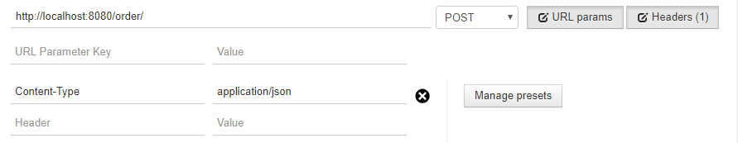

{

"userAccountId": "1",

"username": "zhangsan",

"consignee": "张三",

"deliveryAddress": "上海市",

"consigneeCellPhoneNumber": "18904587632",

"freight": 16.5,

"payType": 1,

"totalAmount": 600,

"discountAmount": 20,

"couponAmount": 20,

"payableAmount": 576.5,

"invoiceTitle": "上海市某公司",

"taxpayerId": "测试纳税人编号",

"orderComment": "测试订单",

"orderItems": [

{

"goodsId": 1,

"goodsSkuId": 1,

"goodsSkuCode": "测试",

"goodsName": "测试商品",

"saleProperties": "测试销售属性",

"goodsGrossWeight": 56.5,

"purchaseQuantity": 3,

"purchasePrice": 34.2,

"promotionActivityId": 1,

"goodsLength": 45.6,

"goodsWidth": 23.5,

"goodsHeight": 14.8

},{

"goodsId": 2,

"goodsSkuId": 2,

"goodsSkuCode": "测试",

"goodsName": "测试商品",

"saleProperties": "测试销售属性",

"goodsGrossWeight": 56.5,

"purchaseQuantity": 3,

"purchasePrice": 34.2,

"promotionActivityId": 1,

"goodsLength": 45.6,

"goodsWidth": 23.5,

"goodsHeight": 14.8

}

]

}

**2、响应结果**

{

"id": null,

"orderNo": "fffcf34063334dd2a8b14ed3afb0e004",

"userAccountId": 1,

"username": "zhangsan",

"orderStatus": 1,

"consignee": "张三",

"deliveryAddress": "上海市",

"consigneeCellPhoneNumber": "18904587632",

"freight": 16.5,

"payType": 1,

"totalAmount": 600,

"discountAmount": 20,

"couponAmount": 20,

"payableAmount": 576.5,

"invoiceTitle": "上海市某公司",

"taxpayerId": "测试纳税人编号",

"orderComment": "测试订单",

"publishedComment": 0,

"confirmReceiptTime": null,

"gmtCreate": 1520691049000,

"gmtModified": 1520691049000,

"orderItems": [

{

"id": null,

"orderInfoId": 2,

"goodsId": 1,

"goodsSkuId": 1,

"goodsSkuCode": "测试",

"goodsName": "测试商品",

"saleProperties": "测试销售属性",

"goodsGrossWeight": 56.5,

"purchaseQuantity": 3,

"purchasePrice": 34.2,

"promotionActivityId": 1,

"goodsLength": 45.6,

"goodsWidth": 23.5,

"goodsHeight": 14.8,

"gmtCreate": 1520691050000,

"gmtModified": 1520691050000

},

{

"id": null,

"orderInfoId": 2,

"goodsId": 2,

"goodsSkuId": 2,

"goodsSkuCode": "测试",

"goodsName": "测试商品",

"saleProperties": "测试销售属性",

"goodsGrossWeight": 56.5,

"purchaseQuantity": 3,

"purchasePrice": 34.2,

"promotionActivityId": 1,

"goodsLength": 45.6,

"goodsWidth": 23.5,

"goodsHeight": 14.8,

"gmtCreate": 1520691050000,

"gmtModified": 1520691050000

}

]

}

**3、数据库现场**

（1）order\_info表



（2）order\_item表

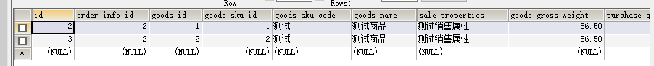

## 2.4 查询订单列表

**1、数据库现场**

（1）order\_info表



（2）order\_item表



**2、请求参数**

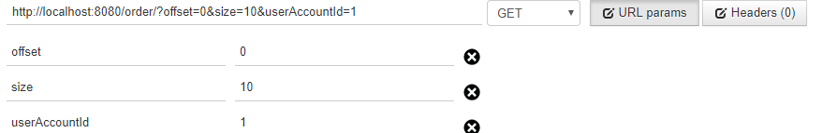

**3、响应结果**

[

{

"id": 2,

"orderNo": "fffcf34063334dd2a8b14ed3afb0e004",

"userAccountId": 1,

"username": "zhangsan",

"orderStatus": 1,

"consignee": "张三",

"deliveryAddress": null,

"consigneeCellPhoneNumber": null,

"freight": 16.5,

"payType": 1,

"totalAmount": 600,

"discountAmount": 20,

"couponAmount": 20,

"payableAmount": 576.5,

"invoiceTitle": null,

"taxpayerId": null,

"orderComment": null,

"publishedComment": null,

"confirmReceiptTime": null,

"gmtCreate": 1520691049000,

"gmtModified": null,

"orderItems": [

{

"id": 2,

"orderInfoId": 2,

"goodsId": 1,

"goodsSkuId": 1,

"goodsSkuCode": "测试",

"goodsName": "测试商品",

"saleProperties": "测试销售属性",

"goodsGrossWeight": 56.5,

"purchaseQuantity": 3,

"purchasePrice": 34.2,

"promotionActivityId": 1,

"goodsLength": 45.6,

"goodsWidth": 23.5,

"goodsHeight": 14.8,

"gmtCreate": 1520691050000,

"gmtModified": 1520691050000

},

{

"id": 3,

"orderInfoId": 2,

"goodsId": 2,

"goodsSkuId": 2,

"goodsSkuCode": "测试",

"goodsName": "测试商品",

"saleProperties": "测试销售属性",

"goodsGrossWeight": 56.5,

"purchaseQuantity": 3,

"purchasePrice": 34.2,

"promotionActivityId": 1,

"goodsLength": 45.6,

"goodsWidth": 23.5,

"goodsHeight": 14.8,

"gmtCreate": 1520691050000,

"gmtModified": 1520691050000

}

],

"logs": null

}

]

## 2.5 查询订单详情

**1、数据库现场**

（1）order\_info表



（2）order\_item表



（3）order\_operate\_log表

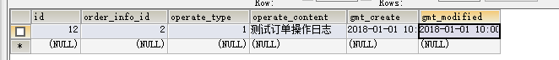

**2、请求参数**

IMG_256

1. **响应结果**

{

"id": 2,

"orderNo": "fffcf34063334dd2a8b14ed3afb0e004",

"userAccountId": 1,

"username": "zhangsan",

"orderStatus": 1,

"consignee": "张三",

"deliveryAddress": "上海市",

"consigneeCellPhoneNumber": "18904587632",

"freight": 16.5,

"payType": 1,

"totalAmount": 600,

"discountAmount": 20,

"couponAmount": 20,

"payableAmount": 576.5,

"invoiceTitle": "上海市某公司",

"taxpayerId": "测试纳税人编号",

"orderComment": "测试订单",

"publishedComment": null,

"confirmReceiptTime": null,

"gmtCreate": 1520691049000,

"gmtModified": null,

"orderItems": [

{

"id": 2,

"orderInfoId": 2,

"goodsId": 1,

"goodsSkuId": 1,

"goodsSkuCode": "测试",

"goodsName": "测试商品",

"saleProperties": "测试销售属性",

"goodsGrossWeight": 56.5,

"purchaseQuantity": 3,

"purchasePrice": 34.2,

"promotionActivityId": 1,

"goodsLength": 45.6,

"goodsWidth": 23.5,

"goodsHeight": 14.8,

"gmtCreate": 1520691050000,

"gmtModified": 1520691050000

},

{

"id": 3,

"orderInfoId": 2,

"goodsId": 2,

"goodsSkuId": 2,

"goodsSkuCode": "测试",

"goodsName": "测试商品",

"saleProperties": "测试销售属性",

"goodsGrossWeight": 56.5,

"purchaseQuantity": 3,

"purchasePrice": 34.2,

"promotionActivityId": 1,

"goodsLength": 45.6,

"goodsWidth": 23.5,

"goodsHeight": 14.8,

"gmtCreate": 1520691050000,

"gmtModified": 1520691050000

}

],

"logs": [

{

"id": 12,

"orderInfoId": 2,

"operateType": 1,

"operateContent": "测试订单操作日志",

"gmtCreate": 1514772000000,

"gmtModified": 1514772000000

}

]

}

## 2.6 自动取消订单

对于状态为待付款的，而且订单创建时间超过了24小时的订单，会自动取消：

1. 将订单状态设置为：已取消
2. 新增一条订单操作日志：是自动取消订单的操作日志